**MINE SAFE : IOT BASED SMART HELMET FOR MINING WORKERS**

**ABSTRACT:** Mining is recognized as one of the most hazardous occupations globally. The death rate of mining workers at mining sites is increasing day by day. Considering this, we cannot simply avoid mining because it plays a vital role. Instead, an alternative solution is to implement safety measures and continue operations in mines.

To ensure the well-being of workers and protect them from potential health hazards, we propose a smart and adaptable helmet for workers. This advanced helmet incorporates a range of specialized sensors to monitor both environmental conditions and workers health. Environmental monitoring is facilitated by Gas sensor, Temperature and Humidity sensor, ensuring that workers are protected from hazardous conditions. Simultaneously, the helmet employs Accelerometer and Gyroscope sensors, IR sensor, Heart Rate sensor to monitor worker's conditions. Furthermore, an integrated emergency button enables miners to request help swiftly, triggering alerts that pinpoint their exact location. Instead of relying on traditional loud alarms, the helmet communicates crucial information to the miner through a voice interface, offering real- time updates and guidance during emergency situations. The developed helmet system is primarily intended to improve the working environment in mines and ensure worker safety.

**Keywords** : Smart Helmet, Accelerometer and Gyroscope sensor, Voice interface module.

**1. INTRODUCTION**

In the contemporary landscape of industrial innovation and technological advancement, the integration of smart solutions has become increasingly pivotal across various sectors. One such domain that has witnessed transformative developments is the mining industry, a cornerstone of economic prosperity for nations worldwide. **This paper** delves into the critical intersection of technology and mining safety, addressing the multifaceted challenges faced by miners and proposing an innovative approach to enhance their well-being and security. Mining is indispensable for the economy of every country, providing numerous opportunities across various industries. The benefits generated by this industry contribute significantly to local communities by processing the materials it offers. However, working in mining poses specific health and safety risks, especially in challenging or unpredictable conditions. As mines expand, the risks associated with completing tasks also increase. The mining industry is complex, involving intricate operations conducted within tunnels, underground passages, and other challenging environments. This complexity introduces various risk factors that can impact the health of miners. The Chasnala mining disaster near Dhanbad in the Indian state of Jharkhand, which nearly claimed the lives of 372 miners, stands as one of the worst disasters in the mining sector.

Miners often face external conditions, such as temperature and pressure fluctuations, without awareness. Excavators may collide with heavy objects like mining equipment or hard rocks, putting their lives in extreme danger. Another significant threat to miners is the inhalation of hazardous gases, exposing them to potential harm. In such situations, miners are unable to communicate with the outside world.

Recognizing the need for proactive safety measures, **this paper** explores the development of a smart protective helmet system designed to detect and respond to hazardous events in real-time. Beyond event detection, the system encompasses environmental monitoring, GPS tracking, and the provision of oxygen enhancements to mitigate risks associated with toxic gases. The proposed system not only addresses the immediate safety concerns but also serves as a forward-looking initiative to ensure the well-being of miners in the evolving landscape of the mining industry.

Moreover, considering the rising prominence of the mining sector in certain regions, such as Pakistan with its substantial coal reserves, **the paper** discusses the challenges faced in ensuring the safety of miners. The convergence of technological solutions, such as microcontroller-based monitoring systems and the Internet of Things (IoT), emerges as a pivotal strategy to overcome these challenges and fortify the safety infrastructure within the mining industry.

In navigating this discourse, the aim is to contribute to the ongoing dialogue on mining safety by presenting an integrated and forward-thinking approach. By leveraging cutting-edge technologies and innovative solutions, we strive to redefine the safety paradigm for miners, fostering a safer, more secure environment for those working at the heart of economic prosperity.

**2. LITERATURE SURVEY**

[1] T.Sowmya, G.SrinivasaRao, Ch.Sruthi, I.Tanuja, I.Bhavya, M.Sindhu Priya proposed a system which uses various sensors to monitor the workplaces. It incorporated sensors like MQ2 Sensor for detecting hazardous gases, DHT11 sensor keeps track of the environment's temperature and humidity. The Smart helmet also integrated with a GSM modem to send emergency SMS messages to predefined numbers, GPS location tracking, and WiFi module for IoT communication. This system is particularly used for detecting safety at workplaces but not for the workers.

[2] Jeya Seelan S, Krittika J, Cerene Eunice Getsiah C, Arunachalam B introduces an Intelligent Helmet system equipped with various sensors and utilizing Zigbee protocol for real-time monitoring of hazardous conditions. The proposed system integrates multiple sensors, including temperature, methane gas, and heart rate, with a Zigbee mesh network ensuring reliable data transmission for timely alerting and emergency response.

[3] GAO junyao, GAO xueshan, ZHU wei, ZHUjianguo, WEI boyu proposed a wearable IoT-enabled jacket specifically crafted to safeguard individuals employed in coal mines, often subjected to potential hazards. This prototype is engineered to detect multiple factors such as harmful chemicals, the heartbeat of a coal miner, underground conditions, and the miner's GPS location. The collected data is intended to be transmitted to a dynamic internet protocol using a Wi-Fi encrypted channel.

**3. EXISTING SYSTEM**

In the existing mining system, the conventional helmet functions as a protective measure against potential hazards, ensuring the safety of miners. However, this system has inherent limitations. While the primary purpose of the helmet is to shield the head from injuries, challenges arise in maintaining environmental awareness. The weight and discomfort of the helmet often prompt miners to remove it, subjecting them to unsafe conditions. Additionally, the existing system lacks fall detection capabilities, presenting a potential risk as workers may faint and fall unexpectedly, particularly when exposed to dangerous gases in the mining area. Miners also face the danger of colliding with substantial objects like mining equipment or hard rocks, exposing them to severe life-threatening risks. In such scenarios, a fall detection sensor plays a crucial role, addressing a significant gap in the capabilities of existing helmets.

The current alert system relies on a buzzer, which activates in the event of any abnormal condition. However, it lacks specificity regarding the particular condition, making it challenging to discern the reason for the alert. Having a system that specifies the exact cause during alerts would enhance our understanding and enable us to respond more cautiously to the identified cause.

**4. PROPOSED SYSTEM**

We have developed an advanced protective helmet embedded with a sophisticated array of sensors designed for comprehensive detection and analysis. The primary sensor categories include environmental sensors and sensors for monitoring the condition of workers. Within the environmental sensor suite, we employed a gas sensor to detect hazardous gases, along with temperature and humidity sensors to detect abnormal fluctuations in temperature and humidity. Additionally, for monitoring the worker’s condition, we've integrated sensors such as a pulse sensor for tracking the worker's heart rate, an infrared sensor to ensure continuous helmet usage, and a MEMS sensor for detecting sudden falls.

Fig-1: Block Diagram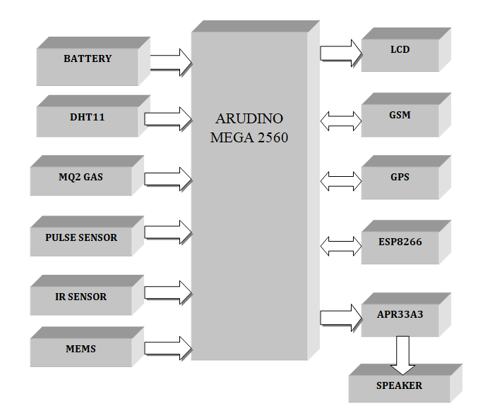

These sensors consistently monitor both environmental conditions and the well-being of workers. When abnormal conditions arise, and the tracked values exceed predefined thresholds, the system triggers a sound alert. Unlike traditional buzzers, we employ an APR33A3 voice module which provides a sound alert that specifies the exact cause. Along with the localized alerts, the system sends alert messages to registered mobile numbers, including GPS location details facilitated by GSM and GPS modules. To ensure data retention for future references and predictive analyses, a WiFi module is utilized to store information on ThingSpeak. This comprehensive system signifies a cutting-edge solution that enhances workplace safety through real-time monitoring, accurate alerts, and data-driven insights.

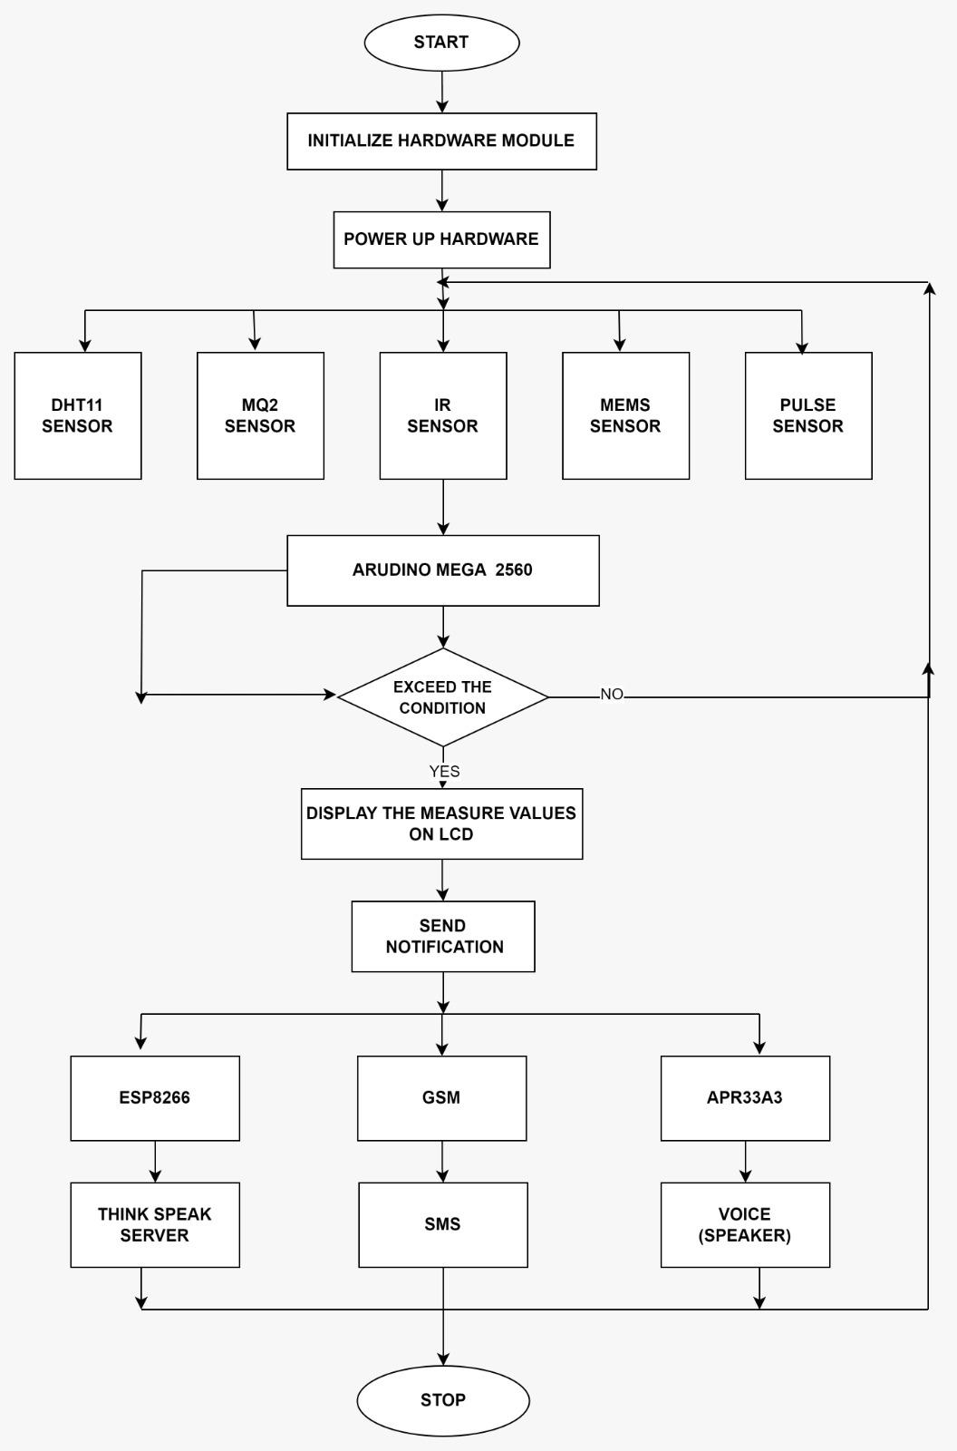

Fig-2: Flow Chart

**5. CONCLUSION AND FUTURE**

**SCOPE**

In conclusion, the integration of IoT-based smart helmets in the mining industry marks a significant advancement in ensuring the safety and well-being of miners. The existing system, relying on traditional helmets, demonstrates certain limitations, particularly in maintaining environmental awareness, fall detection, and specifying the exact cause during alerts. The proposed smart helmet system addresses these gaps by integrating various sensors, including a gas sensor and temperature/humidity sensor for environmental monitoring, ensuring protection against hazardous conditions. Additionally, the helmet utilizes MEMS sensors, an IR sensor, and a heart rate sensor to monitor workers' conditions. Moreover, the system is enhanced by an efficient alerting system, incorporating a voice interface module (APR33A3) and robust communication system by GSM and GPS modules. To facilitate data retention for future references and predictive analyses, a WiFi module is employed to store information on ThingSpeak. This holistic system represents an advanced solution that elevates workplace safety through real-time monitoring, precise alerts, and insights derived from data analysis. Beyond safety enhancement, this comprehensive solution also contributes to improved communication, emergency response, and overall operational efficiency within mining endeavors.

**Future Scope** :

1. The implementation of machine learning algorithms could significantly enhance the system's predictive capabilities, allowing for more accurate accident prevention.

2. Integrate augmented reality features into the helmet to provide real-time data visualization and guidance to miners. This could include displaying environmental conditions, navigation assistance, or equipment operation instructions.

**REFERENCES**

[1]Sowmya T, SrinivasaRao G, Sruthi Ch, Tanuja , I.Bhavya, M.Sindhu Priya, “[Smart Helmet For Mining Workers](https://www.jespublication.com/upload/2023-V14I40142.pdf)”, Journal of Engineering Sciences, Volume. 14, pp. 0377-9254, 2023.

[2] Jeya Seelan S, Krittika J, Cerene Eunice Getsiah C, Arunachalam B, “[IoT Based Intelligent Helmet For Miners](https://iaeme.com/MasterAdmin/Journal_uploads/IJEET/VOLUME_12_ISSUE_3/IJEET_12_03_018.pdf)”, International Journal of Electrical Engineering and Technology, Volume. 12, pp. 123-128, March. 2021.

[3] GAO junyao, GAO xueshan, ZHU wei, ZHUjianguo, WEI boyu. ”Coal Mine Detect and Rescue Robot Design and Research” IEEE 2008.[4] Jong C. Wang, Yan Ting Lin, Huei Teng Jheng, Jyun Sian Wu and Ruei Jhe Li, “Object Tracking for Autonomous Biped Robot” IEEE 2010

[4] Manikandan S, Arun Francis G. Mithya V, Kamal C, Dhilip Kumar S, Hariprasath R, Sankar P, “[A Smart Helmet for Air Quality and Hazardous Event Detection for the Mining Industry](https://www.ijitee.org/wp-content/uploads/papers/v8i12/L39471081219.pdf)”, International Journal of Innovative Technology and Exploring Engineering, Volume. 8, pp. 2278-3075, October. 2019.

[5] Shruti P. Borkar1 , V. B. Baru, “[IoT Based Smart Helmet for Underground Mines](https://www.ijresm.com/Vol_1_2018/Vol1_Iss9_September18/IJRESM_19_11.pdf)”, International Journal of Research in Engineering, Science and Management, Volume. 1, pp. 2581-5782, September. 2018

[6] A.P. Squelch, “Virtual reality for mine safety training in South Africa,” Thes Journal of The South African Institute of Mining and Metallurgy, pp. 209-216, July 2001.

[7] X.B. Jiang, ZigBee technology and its applications [J]. Low-voltage apparatus, 2005 .

[8] Z.J. Tian, Digital Mobile Voice Communication Encode and Voice Communication Designed [J]. China Coal, 2007.

[9] H.M. Zhu and L. Zhang, The Design of Warp Tension Embedded Intelligent Control System Based on μC/OS and ARM [J]. Mechanical & Electrical Engineering Magazine, 2006 .

[10] X. Zhang, X.J. Qiao and E. Liu, Design of High Precision Instrument for Measuring Temperature,Humidity & Dew Point [J]. Instrument Technique and Sensor, 2006 .

[11] L. Ma and H. Guo,Smart Sensor for Underground Coal Mine Based on ZigBee Protocol [J]. Instrument Technique and Sensor, 2007 .

[12] Implementation of Smart Safety Helmet for Coal Mine Workers. In IEEE International Conference on Power Electronics. Intelligent Control and Energy Systems. Jorhat, India, ICPEICES.

[13] Vargas Hernández, J. G., & Plascencia, M. D. L. R. (2017). Application of the IndustryBased Theory the Case of Mexican Company Cemex. Management & Administration (IMPACT: JMDGMA), 1(2), 31-44.

[14] Sanchit Gupta and Rashmi Vashisth, 2017. IMPLEMENTATION AND ANALYSIS OF SMART HELMET. In IEEE International Conference on Signal Processing, Computing and Control (ISPCC 2k17). Solan, India, Sep21-23, 2017, IEEE.

[15] Chang, W. Y., & Chang, P. C. (2018). Application of Radial Basis Function Neural Network, to Estimate the State of Health for LFP Battery. International Journal of Electrical and Electronics Engineering (IJEEE), 7(1), 1-6.

[16] Praveen Kulkrani and Sangam, “Smart System for Hazardous Event Detection and Evaluation in Mining Industries,”. International Journal of Innovative Research in Electrical, Electronics, Instrumentation and Control Engineering, 5th Vol 3rd Issue, 2017.

[17] SHARMA, S., & KUMAR, G. (2016). A dual Wideband Stair Shape Microstrip Patch Antenna for C & X Band. International Journal of Electronics and Communication Engineering (IJECE), 5(4), 1-8.